CS6P05 Project Proposal Guidelines

The content and format of a project proposal depends on the area of the project. The CS6P05 project is a core module for a number of courses from Computing, Business & IT, Cyber Security and Digital Forensic / Computer Networking.

The **British Computer Society** accreditation requirement dictates that

***“All projects should reflect the aims and learning outcomes which characterise the programme to which they contribute as set out in the programme specification”***

Hence, there are specific requirement for the project in each specialist area of your BSc programme, and it is always best to check if your supervisor would like you to add additional information in the proposal which may be specific to your project. The guidelines presented here are therefore general in nature.

**Note:** Before we start, a small note that applies to the rest of the documentation that you are going to submit; the style and appearance of your report is a strong indication of its content. Have a consistent use of fonts/spacing for Titles, subtitles and the text. Each section of your document should follow immediately from the previous section (don’t have a single page for each section that has two lines of text. )

**The Length of the Proposal with Project Plan:** Normally two A4 pages but maximum of three A4 pages.

**PROJECT PROPOSAL**

The project proposal is an agreement between you and your supervisor. It normally has the following minimum sections:

# Project Title

This would appear at the top of the page and includes: Your project title, your details, your supervisor details and contacts. Here is an example:

**An Innovative Interactive Web Application for Learning Foreign Languages**

**James Smith (j.smith@londonmet.ac.uk), ID: 16002546**

***BSc. Computer Science***

**Supervisor: Dr. M. Jones**

**Introduction**

**~ ~ ~ ~ ~ ~ ~**

**Note** that there is no need to have a single page just for the Title of the project. The next section of the proposal that is an ‘Introduction’ appears immediately after the tile section on the same page.

# Introduction and Rationale

In this section, you should explain ‘**why**’ you are doing the project. A brief overview of the background to the project which highlights the need for the project.

## Aims and Objectives

This section defines your project at two levels. At the top level you define your project’s aims in terms of the problem to be solved and the end-product of the project. At the second level, concrete and measurable objectives should be identified in order each of the stated aims to be realised and achieved.

# Expected Outcomes and Deliverables

This section should give a concise description of the product that will be expected at the end of your project. This could include a piece of software with the technical and user documentation, a computer models and algorithms as a solution for a specific problem, a tailored -made IT / Security solution for a real-world business, etc.

## Methodology

This section is to propose a *methodological* roadmap in order to achieve the expected outcome. It outlines how the project will be undertaken, for example by:

* following a software development methodology (e.g. UML Unified Process, Agile software development);
* conducting a survey using a series of quantitative and qualitative questionnaires;
* developing a computational and/or data analytic model;
* reading and critically reviewing a number of authoritative research papers;
* designing and conducting case studies and/or doing fieldwork; etc

# Resource Requirements

This section identifies any resource requirements for your project, for example: -

* *specialist* hardware and/or software e.g. web hosting service, forensic toolbox;
* access to any external datasets;
* IT system / staff of a specific company;
* specialist research journals and libraries.

## Bibliography & References

Here, you need to list 5-7 relevant authoritative printed books, specialist journals, recent research publications of the specialist area of your chosen project topic. This is obviously not a definitive list and can only be one or two references that you have found very useful up until now and you will be referring to throughout your project work. This is especially important for Research / Investigative type of project. The Harvard referencing is should be used for this list.

**PROJECT PLAN**

The project plan is an integral part of your project proposal, which shows that your project is feasible and that you have concrete ideas of what work to be done in order to achieve a successful completion of your project, within the available time and resources.

## As a minimum your project plan should include: (1) a table of the project WBS activities (see Table 1 below), (2) a list/graph of milestones and (3) a project Gantt chart.

It is expected that you apply what you learned about the project management techniques in your previous studies or modules such as CS5002 - Software Engineering, CC5006 - Project Management, Systems Development and Usability, or CC5004 - Security in Computing (viz. Learning outcome LO9).

## Project work breakdown structure

In order to develop your project work breakdown structure (***WBS***) your above listed project’s objectives should be further refined using the SMART technique (SMART is an acronym for Specific, Measurable, Achievable, Realistic and Time-related).

Given the level of complexity of your undergraduate project I would suggest 3 to 4 relatively disparate ***areas*** should be identified from your project’s objectives.

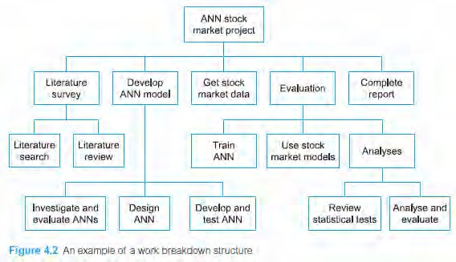

It is recommended that the work in each of the areas should be completed within between 4 to 8 weeks. Then each of the identified areas could be further broken down into 2 to 3 ***activities*** as in the example above (*Source*: *Dawson, C. (2015), Projects in Computing and Information Systems - A Student Guide, 3rd Edition*, page 66. Pearson). For your project, an activity is recommended to have an ***estimated duration*** of 2(+ -1) weeks, and there should be no more than a total of 14 activities.

## Table 1: The project WBS activities

|  |  |  |  |
| --- | --- | --- | --- |
| **No.** | **Activities** | **Estimate Duration** | **Activity Description** |
| 1 | Literature Search | 2 weeks | Search, skim-read and filter out 5-7 relevant  authoritative published sources on the project topic. |
| 2 | Literature review | 3 weeks | Scan-read, critical review of the selected publications. |
| xxx | ~~~~ | ~~~~~~ | ~~~~~ |
| zzz | Finalise the report | 2 weeks | Finalise, spell-check, format the report and get it proof-read. |
|  | ***Total duration*** | ***27 weeks*** |  |

**Project milestones**

Milestones are critical temporal points in your project life time. They help you to wrap up and appraise the project’s interim deliverables during your project process. You should determine your own project milestones being based on your work breakdown structure and the provided CS6P05 project milestones on WebLearn.

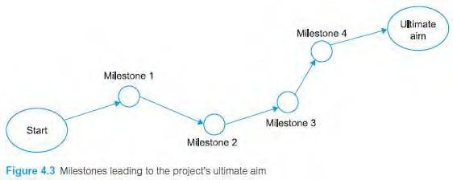

*Source*: Dawson, C. (2015), page 68

## Project Activity Sequencing

While the WBS estimates the individual activity’s duration the “Activity sequencing” determines the *logical*, temporal sequence between the activities. For example, the activity “Literature review” cannot be started before the completion of the activity “Literature search” from Figure 4.2 above.

However, “Get stock market data” activity could virtually start soon after the project began, then being concurrently done with the other activities of the WBS from Figure 4.2.

## Project Gantt Chart, incorporating Milestones

A Gantt chart is a simple but very effective graphical representation of the results obtained from the project’s WBS, milestones and activity sequencing, which were very briefly described above. Below is an example of a project Gantt chart.

**Note**: Your project Gantt chart’s time axis must be measured in **weeks**.

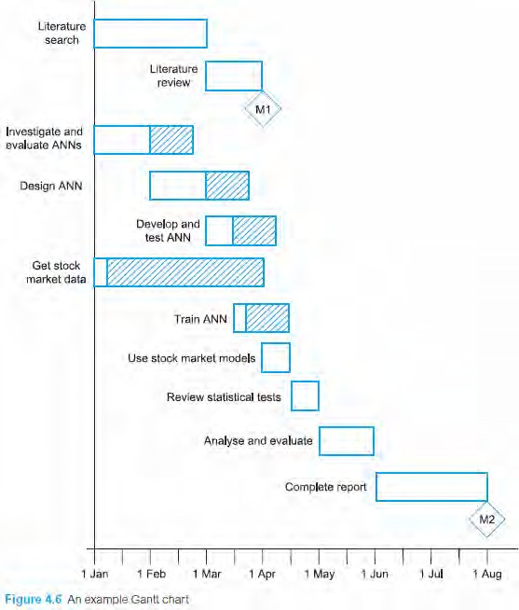

*Source*: Dawson, C. (2015), page 74

## Recommended reading

* Dawson, C. (2015), Projects in Computing and Information Systems - A Student Guide, 3rd Edition, Pearson; **Chapters 3 and 4.**

# CS6P05 Project Proposal Marking Scheme

|  |  |  |
| --- | --- | --- |
| **Criteria** | **Description** | **Weighting**  **%** |
| 1 | Is the **project topic** suitable, useful and relevant to the specialism of  the student's BSc course? | 10 |
| 2 | Is the project **Title** clear & concise? Are the student name & ID and  supervisor name correct? | 5 |
| 3 | **Introduction**: A brief overview of the background to the project which  highlights the need for the project. | 10 |
| 4 | **Aims and Objectives**: At the *top level*, there should be clear and specific project’s aims in terms of the problem to be solved and the end-product of the project; At the *second level*, concrete and measurable objectives should be identified in order each of the stated  aims to be realised and achieved. | 10 |
| 5 | **Expected Outcomes and Deliverables**: a concise description of the product that will be expected at the end of the project. This could include a piece of software with the technical and user documentation, a computer models and algorithms as a solution for a specific problem,  a tailored -made IT / Security solution for a real-world business, etc. | 5 |
| 6 | **Methodology**: a sensible and cogent methodological roadmap in order to achieve the expected outcome. It outlines how the project will be  undertaken. | 10 |
| 7 | **Resource Requirements**: identifies any resource requirements for your project, including specialist hard/software, publications (journals,  dataset etc.), access to a company IT resources etc. | 5 |
| 8 | **Bibliography & References**: 5-7 relevant authoritative printed books, specialist journals, recent research publications of the specialist area of  the chosen project topic. | 5 |
| 9 | Table of the project **work breakdown structure's activities** with duration and description: appropriate concrete activities with suitable  duration and description. | 5 |
| 10 | List/graph of appropriate **milestones** with annotation. | 5 |
| 11 | **Project Gantt chart** with correct activity sequencing, duration and milestones: well formatted Gantt chart with appropriate logic and  annotations. | 30 |
|  | **Overall Grade** | 100% |

**Table 1: Marking Guidelines**

|  |  |
| --- | --- |
| ***Grade*** | ***Characterised by*** |
| **0-19** | **No work** or work totally irrelevant. |
| **20-29** | **Unacceptable** level of competency. The overall standard is very weak and very few learning outcomes are achieved. |
| **30-39** | A very **weak** level of competency. Use of insufficient skills to apply knowledge and understanding in a range of activities demonstrating a weak comprehension of relevant theories and practices. |
| **40-44** | A **basic** level of competency. Use of very basic skills to apply knowledge and understanding in a range of activities demonstrating a basic comprehension of relevant theories and practices. |
| **45-49** | An **acceptable** level of competency. Use of basic skills to apply knowledge and understanding in a range of activities demonstrating an acceptable comprehension of relevant theories and practices. |
| **50-54** | A **satisfactory** level of competency. Use of limited skills to apply knowledge and understanding in a range of activities demonstrating a satisfactory comprehension of relevant theories and practices |
| **55-59** | A **fairly good** level of competency. Use of limited skills to apply knowledge and understanding in a range of activities demonstrating a fairly good comprehension of relevant theories and practices. |
| **60-64** | A **good** level of competency. Use of skills to apply knowledge and understanding in a range of activities demonstrating a good comprehension of relevant theories and practices. |
| **65-69** | A **very good** level of competency. Use of skills to apply knowledge and understanding in a range of activities demonstrating a very good comprehension of relevant theories and practices. |
| **70-79** | An **excellent** level of competency of a complex and specialised area of study. Use of **advanced skills to apply** knowledge and skills in a range of complex activities demonstrating **excellent** comprehension of relevant theories and practices. |
| **80-89** | An **outstanding** level of competency of a complex and specialised area of study. Use **of advanced skills to critically evaluate** concepts and apply knowledge and understanding in a range of activities demonstrating an outstanding comprehension of relevant theories and practices. |
| **90-100** | Display **mastery** of a complex and specialised area of study. Use of **advanced skills to critically evaluate** concepts and apply knowledge and understanding in a range of activities demonstrating an **exceptional** comprehension of relevant theories and practices. |